FTP Package Deployment Guide

Contents

Document History 2

Document Overview 4

Related Documents 5

1 Environment Preparation 6

2 Deploy Package 7

2.1 Copy Software 7

2.2 Deploy Software 7

3 Managing Databases 8

3.1 Adding Databases to SQL Server High Availability 8

3.1.1 Set Databases to Full Recovery Model. 8

3.1.2 Execute a Full Backup to NULL 8

3.1.3 Add databases back into HA Availability Groups. 9

3.1.4 Synchronising Mirrored Databases 10

3.1.5 External PCS Configuration 10

3.2 Service Broker with Multiple Databases 11

3.3 Re enable SQL agent jobs 11

4 Pare Service Cluster Configuration and Verification 12

4.1 Configure Service Cluster 12

4.2 Validate Pare Service Cluster 13

4.3 Notes 13

5 Automated Post-Deployment Tests 14

5.1 Deployment Logs 14

5.1.1 Database Deployment Logs 14

5.1.2 Deployment Summary Log 14

5.1.3 Deployment Details Log 15

Appendix A: Site A - SiteB Setup 16

Appendix B: Environment Pre-requisites 17

Service Accounts 17

Log on as a service right 17

SQL Server Instances. 17

SQL Server Database File Storage 17

Deployment Server 18

External Web Servers 18

Appendix C: Updating Encrypted Security Files 19

Appendix D: Setup BaseData 20

Setup BaseData 20

Using an Alternative BaseData DB 21

Appendix E: IIS Management 22

Remote IIS Management 22

Appendix F: End of Day Controller Scheduling 23

Appendix G: Managing Clustered Services 24

# Document History

The master version of this document is stored by TfL in the FTP TFS Source Control at; $/Deployment/Main/Documents.

Any version of this document not from this location is not controlled.

|  |  |  |  |
| --- | --- | --- | --- |
| **Date** | **Version** | **Changes** | **Changed By** |
| 02/01/2013 | 0.1 | Initial draft started. | Rik Locke |
| 04/01/2013 | 0.3 | Initial draft completed. | Rik Locke |
| 08/01/2013 | 0.4 | Updated with feedback from JB. | Rik Locke |
| 01/02/2013 | 1.0 | Updated with feedback from SG  Added details for configuring for external PCS connections. | Rik Locke |
| 14/02/2013 | 1.1 | Added specific details and screenshots for adding databases to SQL Server HA groups. | Rik Locke |
| 06/03/2013 | 1.2 | Added details for handling SQL Server mirroring after adding databases to SQL Server HA groups. | Rik Locke |
| 11/03/2013 | 1.3 | Updated with some more detailed guidance where required. | Rik Locke |
| 28/03/2013 | 1.4 | Added information on fixing service broker deployments where multiple Pare or Pcs DB's exist on same server. | Rik Locke |
| 28/03/2013 | 1.5 | Added details regarding TdrFileProcess share setup and db file system pre-requisites. | Rik Locke |
| 03/06/2013 | 1.6 | Added more detail, screenshots and clarification in response to feedback from cycle 12 release. | Rik Locke |
| 19/08/2013 | 1.7 | Added IIS Management appendix. | Rik Locke |
| 29/08/2013 | 1.8 | Updated post deployment test command line | Hamada Shather |
| 27/09/2013 | 1.9 | Added information regarding setting up EoD Controller schedules. Plus revision of section on configuration of the FAE controller to pare. | Rik Locke |
| 02/10/2013 | 2.0 | Pare Cluster Config and Verification + Scheduled task update | Hamada Shather |
| 04/10/2013 | 2.1 | Section on encrypting and decrypting service accounts files updated and clarified. | Rik Locke |
| 14/10/2013 | 2.2 | Added site a site b setup appendix | Hamada Shather |
| 03/12/2013 | 2.3 | Added section to manage sql agent jobs during deployment | Hamada Shather |
| 07/01/2014 | 2.4 | Added details about proper FTP shutdown sequence | Rik Locke |
| 09/04/2014 | 2.5 | Added info about second FTM service | Hamada Shather |
| 12/09/2014 | 2.6 | Updated Section 1 to refer to formalised FTP Shutdown process. | Rik Locke |

# Document Overview

This document provides details of installing an FTP software deployment package into a suitable environment.

The processes described in this document are suitable for all of the following environments:

* Development Integration (DevInt),
* Pre-Production (PreProd)
* Staging and
* Live (Site-A/B)

Also, Site-A and Staging SQL Servers are High-Availability enabled. Additional steps relating to this need to be followed.

Notes

The “Deployment Package(s)” refers to the .zip file(s) provided for the deployment.

The “Deployment Config File” file refers to the (non-"Common") xml file in D:\Deploy\<PackageName>\Deployment\Scripts\

Warnings

If copying commands from this document ALWAYS paste and re-cut via a plain text editor as Words character replacement can often cause errors.

Do respect the use of single and double quotes as noted in the command samples. Powershell can be quite particular and changing or omitting these can cause errors running the commands.

Finally, do not copy and paste from notepad when text wrapping is on.

if you do it will insert line feeds into the pasted text attempting to run your command in several chunks.

# Related Documents

Release Notes

Each deployment package is delivered with a Release Note that contains details about all the software in the package and the defects fixed and features added in the deployment.

FTP Environment Technical Docs

The details of all the servers, services and other technical setup details have been separated into Environment Technical docs.

This way each deployment needs only one Release Note and the appropriate environment doc can be referenced depending on what environment is being deployed to.

FTP Software Docs

As the software that can be deployed to a given environment can vary, the details of the software components and configuration of web sites, services etc. Has been separated out from the above Environment Technical docs.

Trouble Shooting Guide

If there are any problems with a deployment then there will be the "FTP Deployment Troubleshooting Guide" which contains information on how to track down problems and possible causes for known previously experienced errors.

The "FTP Deployment Troubleshooting Guide" is stored and controlled in the same location as this document.

Team Build Guide

This guide is intended to cover deploying release packages onto an environment.

If you wish to update an environment directly via a software build, then you can refer to the "FTP Team Build Guide", which is stored and controlled in the same location as this document.

# Environment Preparation

Before deployment can commence, the FTP system needs to be shutdown gracefully.

The FTP Shutdown Procedure is detailed in a separate document.

The Release Note that accompanies the deployment package may also contain additional instructions specific to that release.

This and the aforementioned documents are general to the FTP system. If specific information about the software components or servers is required these can be found in the FTP Software and FTP Environment Technical documents respectively

Finally, there are some specific guidelines about how to perform certain activities in the appendices of this document.

# Deploy Package

## Copy Software

1. Remote Desktop to the deployment server.
2. Copy the deployment packages to the Deployment Server.
3. Extract contents of deployment packages to D:\Deploy\<ZipFileName>

Right-click, Extract All..., will default to this destination directory.

## Deploy Software

1. Remote Desktop to the deployment server (the Internal Jump Server)
2. For each deployment package/drop folder, copy the following command into notepad and replace the <variables> as appropriate.

**< PackageName>:**

This is the name of the directory the zip package was extracted to.

**< DeploymentConfigFileName>**:

Each package contains the config file used to create the package and a series of Common xml files that are included in the main one.

This variable is the name (not the full path) of the xml file in the D:\Deploy\**<PackageName>**\Deployment\Scripts\ directory which does not have common in its name.

Run in a windows command prompt;

powershell -ExecutionPolicy Unrestricted D:\Deploy\**<PackageName>**\Deployment\Scripts\Deploy-RigFromConfig2.ps1 -RigRelativePath '**<DeploymentConfigFileName>**' -Password 'Olymp1c$2012' -DeploymentLogFolder 'D:\Deploy\**<PackageName>**\Logs' -EnableRemoting 0

**WARNING: DO NOT copy and paste the above directly:**

MS Office can do subtle character replacement which will break the command in DOS. Paste and edit via notepad.

At the end of the deployment the script should report that all modules are successfully deployed with the following message;

Deploy-RigFromConfig exiting with code 0

All roles deployed successfully

# Managing Databases

**NOTE**: The standard deployment presumes that there is only one version of the Pare and PCS databases on a given server.

If Pare or PCS databases are deployed to environments that have more than one version refer to section 4.2 on how to fix the Service Broker Routes

## Adding Databases to SQL Server High Availability

After deploying the databases on an environment with SQL Server High Availability (Always On) the following steps need to be performed

### Set Databases to Full Recovery Model.

This is set in the Options section of the database properties.

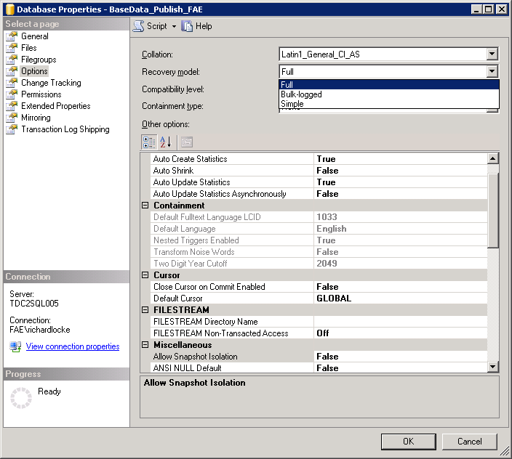

### Execute a Full Backup to NULL

Databases cannot be added to HA if they have an uncommitted transaction log.

Copy this T-SQL into a new query window in Management Studio or open the script from \Deployment\HelperScripts\SQL_Backup_To_NUL.sql

DECLARE @db nvarchar(1024) = DB_NAME()

DECLARE @last_log_backup_lsn numeric(25,0)

DECLARE @recovery_model nvarchar(100)

SELECT @last_log_backup_lsn = last_log_backup_lsn

from sys.database_recovery_status

where database_id = db_id(@db)

SELECT @recovery_model = recovery_model_desc

FROM sys.databases

WHERE name=@db

IF @recovery_model = 'FULL'

BEGIN

IF @last_log_backup_lsn IS NULL

BEGIN

PRINT 'Doing full backup'

backup database @db to disk = 'NUL'

END

PRINT 'Doing log backup'

backup log @db to disk = 'nul'

END

ELSE

PRINT @db + ' is not in Full Recovery'

### Add databases back into HA Availability Groups.

1. Add to group

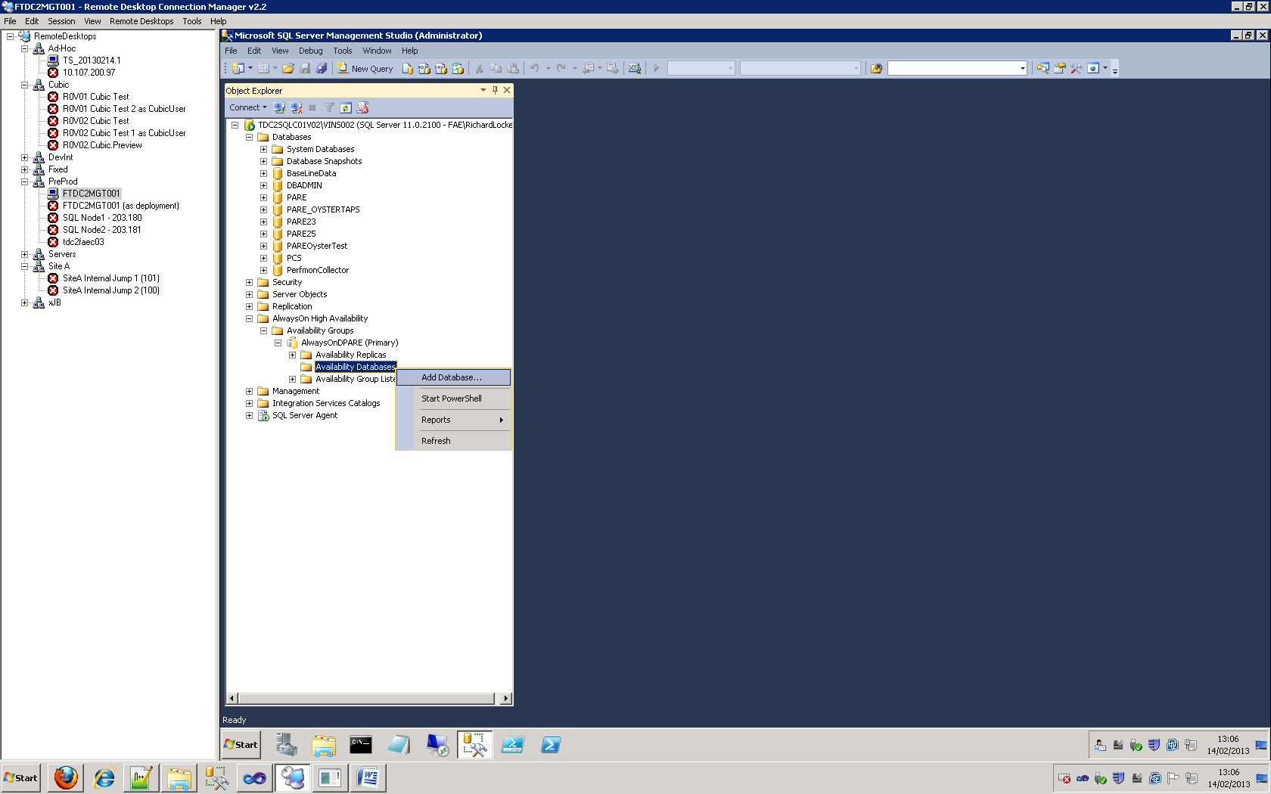

1. The wizard which helps add databases to HA groups will tell you if the pre-requisites are not met.

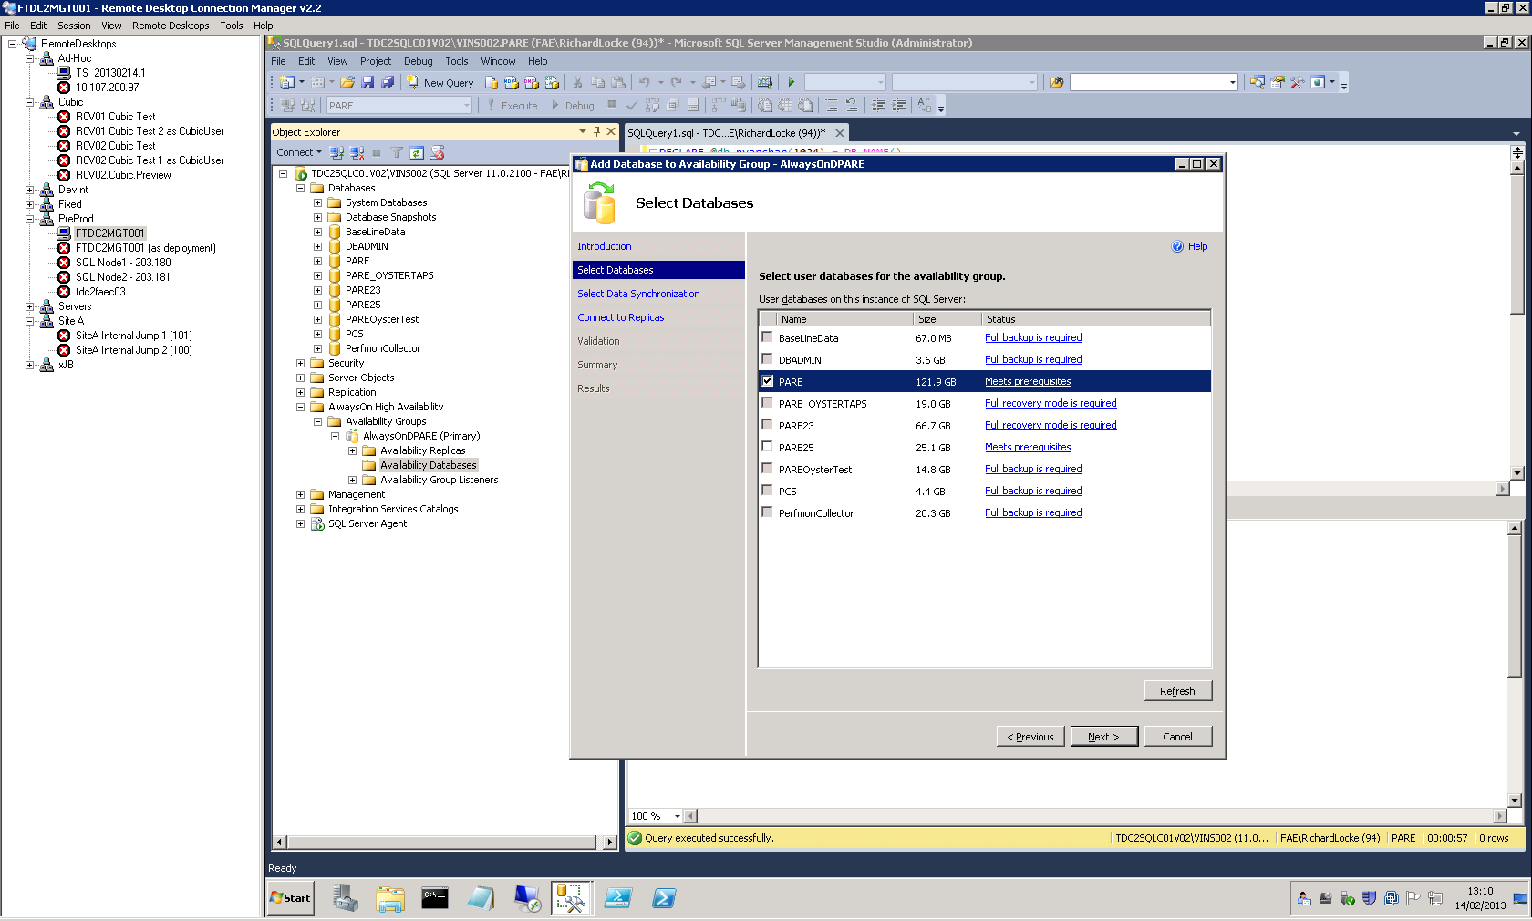

1. Make sure the Skip Initial Data Synchronisation option is selected.

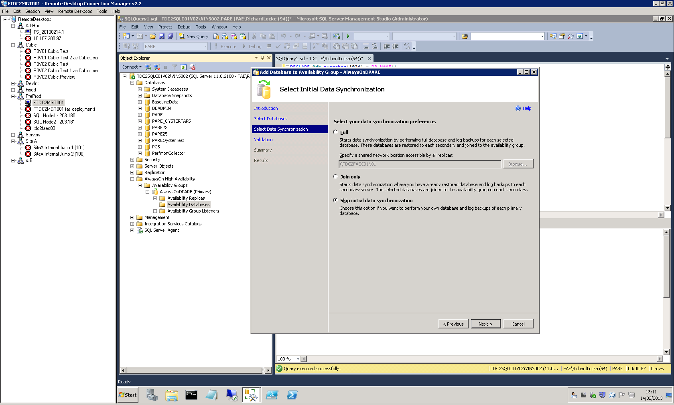

### Synchronising Mirrored Databases

The SQL Server cluster for Site-A and B are also mirrored.

Databases are deployed to Site-A and then synchronised with their Site-B mirrors. There is no database deployment fro Site-B.

If the databases have been deployed from scratch (deleted first or as a new installation) then after they have been added back into the HA groups they must also be re-synchronised.

If a patch deployment is taking place then the mirroring should carry over the changes being applied and so this step is not required.

For each mirrored database:

1. Take a Full Backup of the Database from the Site-A cluster
2. Copy the backup to the Site-B cluster
3. Restore the database on Site-B.

Ensure the NORECOVERY option is selected to enable a log backup to be restored next

Ensure the Use Compression is option is selected (COMPRESSION) to reduce transfer time.

1. Take a Transaction Log Backup of the Database from the Site-A cluster
2. Copy the backup to the Site-B cluster
3. Restore the Transaction Log on Site-B.
4. Add the Site-B Database back into its HA group.

### External PCS Configuration

If the PARE components are being deployed such that they will be connected to an external (Cubic) PCS system then the Service Broker routes will need to be set correctly.

**NOTE**: This simplified approach applies only if there are no other versions of Pare or PCS databases on the servers. If there are multiple versions, see the following section

Run the following script on the PARE database (with <PCS_IP_ADDRESS> replaced as appropriate):

The IP address is that of the SQL Server hosting the Cubic end of the Service Broker deployment.

ALTER ROUTE [http://tfl.gov.uk/Ft/Pare/Authorisation/Routes/Dre/Pcs] WITH ADDRESS = 'tcp://<PCS_IP_ADDRESS>:4022'

ALTER ROUTE [http://tfl.gov.uk/Ft/Pare/Authorisation/Routes/Idra/Pcs] WITH ADDRESS = 'tcp://<PCS_IP_ADDRESS>:4022'

ALTER ROUTE [http://tfl.gov.uk/Ft/Pare/Authorisation/Routes/Se/Pcs] WITH ADDRESS = 'tcp://<PCS_IP_ADDRESS>:4022'

ALTER ROUTE [http://tfl.gov.uk/Ft/Pare/DirectPayment/Routes/Pcs] WITH ADDRESS = 'tcp://<PCS_IP_ADDRESS>:4022'

ALTER ROUTE [http://tfl.gov.uk/Ft/Pare/StatusList/Routes/Pcs] WITH ADDRESS = 'tcp:// <PCS_IP_ADDRESS>:4022'

GO

## Service Broker with Multiple Databases

Service Broker deployment configures routes based on queue names held at the server level.

If there are multiple databases on a server with the same queues then the configuration of routes may connect the wrong databases and cause the system to fail.

There is a script included in the deployment package to do this.

\Deployment\HelperScripts\FixSsbRoutes_DuplicateDBs.sql

This script queries the system tables for the specific Service Broker instance GUID's and usues these to unambiguously configure the routes correctly for the active databases.

The scripts refer to the "PARE" and "PCS" databases so if alternatively named versions of these databases are required to be used then the database names in the script need to be amended accordingly first.

## Re enable SQL agent jobs

Re enable all jobs that were disabled as part of section 1.2

Be sure to leave site b jobs disabled if that is the failover site or vice versa

# Pare Service Cluster Configuration and Verification

## Configure Service Cluster

All configuration information for the service cluster is contained in the release notes.

1. Ensure the cluster is online and all nodes are available to the cluster
2. Ensure all the cluster groups that are specified in the release notes are present and they contain the specified pare services
3. Where a cluster group is specified to contain clustered storage, ensure it does and the drive letter is correct
4. Ensure the file systems specified in the release notes have been created on the clustered drives
5. Ensure the shares specified in the release notes have been created and the specified service accounts have full control on that share and all files and folders within the share. Shares can be created from within the cluster manager using the 'Add shared folder' action. The specified service accounts should be granted full control for both 'Share Permissions' and 'NTFS Permissions'
6. It is also best practice to ensure all support users plus amy admin/SCOM accounts have appropriate access to the shares

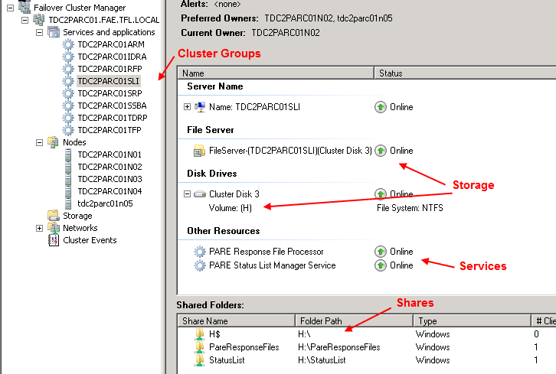

1. Correctly set the 'Autostart' property of each cluster group. e.g. if we are running site A as live, autostart would be set on for site A and off for site B. This setting is in the properties dialog of each cluster group.
2. Ensure each service has it's 'possible owners' set correctly. These are specified in the release notes. Right click on each service and select properties. Go to the advanced tab to set the possible owners.

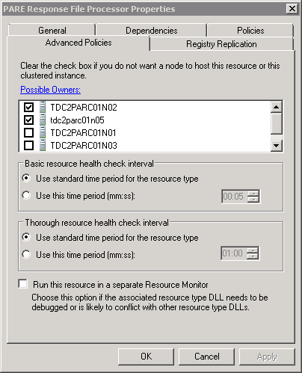

## Validate Pare Service Cluster

1. Bring all pare services on line within the cluster and verify they actually come online. Move each Cluster Group to run on it's default node.

## Notes

1. If you ever to delete a cluster group be sure to connect to Active Directory and delete the computer account that was created for that cluster group. This is not done automatically and it can cause issues if it is left in Active Directory

# Automated Post-Deployment Tests

For each deployment package/drop folder, copy the following command into notepad and replace the <variables> as appropriate.

Run in a standard windows command prompt;

“<DropFolder>\Deployment\Tools\Deployment Tool\DeploymentTool.exe” -Type 'Post' -ConfigFile '<DeploymentConfigFile>' -Password 'Olymp1c$2012'

The <DeploymentConfigFile> parameter is the full absolute path to the file.

## Deployment Logs

A number of log files are produced by the deployment script

### Database Deployment Logs

D:\DatabaseDeployment\*dacpac.log

Sample output:

Publishing to database 'PARE' on server 'tdc2faec03v02\vins002'.

Creating PARE...

Creating [dbo].[SimulatorMessageScenario]...

Creating [dbo].[SimulatorMessageType]...

Creating [dbo].[SimulatorReceiveLog]...

Creating [dbo].[SimulatorSendLog]...

Creating Default Constraint on [dbo].[SimulatorReceiveLog]....

Creating Default Constraint on [dbo].[SimulatorSendLog]....

Creating [dbo].[ClearSimulatorData]...

Creating [dbo].[SimulatorEmptyQueues]...

Creating [dbo].[SimulatorReEnableStatusListQueue]...

Creating [dbo].[SimulatorSendMessage]...

The module 'SimulatorSendMessage' depends on the missing object 'dbo.SsbSendOnRawConversation'. The module will still be created; however, it cannot run successfully until the object exists.

Creating [dbo].[SimulatorStatusListUpdateResponseReceive]...

(1 row(s) affected)

:

(1 row(s) affected)

.

.

.

(1 row(s) affected)

:

(1 row(s) affected)

Update complete.

Successfully published database.

### Deployment Summary Log

<DeploymentLogFolder>\DeploymentSummary.*.log

Sample output:

################################################################################

### STARTING Deploy-RigFromConfig for PreProd.Internal.xml

################################################################################

Successfully installed WebDeploy on FTDC2CIS001

Successfully deployed WebDeploy role 'CSC Web Service' to FTDC2CIS001

Successfully deployed WebDeploy role 'CSC Lookup Service' to FTDC2CIS001

Successfully deployed WebDeploy role 'CSC Membership Service' to FTDC2CIS001

Successfully deployed WebDeploy role 'CSC Admin Membership Service' to FTDC2CIS001

Successfully deployed WebDeploy role 'Pare.TravelTokenService' to FTDC2CIS001

Successfully deployed WebDeploy role 'FAE Journey Usage Service' to FTDC2CIS001

Successfully installed WebDeploy on FTDC2CIS002

Successfully deployed WebDeploy role 'CSC Web Service' to FTDC2CIS002

Successfully deployed WebDeploy role 'CSC Lookup Service' to FTDC2CIS002

Successfully deployed WebDeploy role 'CSC Membership Service' to FTDC2CIS002

Successfully deployed WebDeploy role 'CSC Admin Membership Service' to FTDC2CIS002

Successfully deployed WebDeploy role 'Pare.TravelTokenService' to FTDC2CIS002

Successfully deployed WebDeploy role 'FAE Journey Usage Service' to FTDC2CIS002

Successfully installed WebDeploy on FTDC2CIS003

.

.

.

Successfully installed WebDeploy on FTDC2CAS001

Successfully deployed WebDeploy role 'CACC Support' to FTDC2CAS001

Successfully installed WebDeploy on FTDC2CAS002

Successfully deployed WebDeploy role 'CACC Support' to FTDC2CAS002

Successfully deployed ServiceDeploy role 'FAE Controller' to FTDC2FAC001

Successfully deployed MsiDeploy role 'RSP Exporter' to FTDC2FAC001

Successfully deployed ServiceDeploy role 'FAE Controller' to FTDC2FAC002

Successfully deployed MsiDeploy role 'RSP Exporter' to FTDC2FAC002

Successfully deployed FileSystem role 'PARE File System' to FTDC2PAI001

Successfully deployed ServiceDeploy role 'PARE Services' to FTDC2PAI001

Successfully deployed MsiDeploy role 'SSB Activator Installer' to FTDC2PAI001

Successfully deployed FileSystem role 'PARE File System' to FTDC2PAI002

Successfully deployed ServiceDeploy role 'PARE Services' to FTDC2PAI002

Successfully deployed MsiDeploy role 'SSB Activator Installer' to FTDC2PAI002

Successfully deployed ServiceDeploy role 'FAE Engine' to FTDC2FAE001

Successfully deployed ServiceDeploy role 'FAE Engine' to FTDC2FAE002

Successfully deployed ServiceDeploy role 'FAE Engine' to FTDC2FAE003

.

.

.

Successfully deployed ServiceDeploy role 'FAE Engine' to FTDC2FAE016

Successfully deployed ServiceDeploy role 'FAE Engine' to FTDC2FAE017

Successfully deployed ServiceDeploy role 'FAE Engine' to FTDC2FAE018

Deploy-RigFromConfig exiting with code 0

All roles deployed successfully

##############################################################################

### END Deploy-RigFromConfig for PreProd.Internal.xml

##############################################################################

### Deployment Details Log

<DeploymentLogFolder>\Deployment.*.log

Sample output:

Publishing to database 'Pare' on server 'TS-DB1\Inst2'.

Creating [PARE]...

Creating [PARE].[EmptyStaging]...

Creating [PARE].[StageDayKeysGet]...

Creating [pare].[StageSyntheticTapInsert]...

Creating [PARE].[StageSyntheticTapsBatch]...

Creating [PARE].[StageTapCountGet]...

Creating [PARE].[StageTapForModuloAndDateRangeGet]...

TSRig Post-Deployment Script

Update complete.

Successfully published database.

# Site A - SiteB Setup

In normal circumstances we would be running with Site A on and Site B off.

After post deployment verification, all Site B services will be running. These need to be manually stopped once post deployment validation is complete

|  |  |  |
| --- | --- | --- |
| **Service** | **Site A** | **Site B** |
| FAE Controller | Started | Stopped |
| FAE Pipelines | Started | Stopped |
| File Sync Service | Started | Stopped |
| Pare Cluster Groups | Groups Online/ Autostart = On | Groups Offline/ Autostart = Off |

# Environment Pre-requisites

## Service Accounts

Pare, Fae and Casc service accounts need to be setup on the target internal domain.

The precise account names used for an environment are held in the Service Accounts file (in <DropFolder>\Deployment\Config\)

These accounts require:

* ‘Log on as a service’ rights.
* Access to all SQL Server instances.

## Log on as a service right

From Start Menu/Administrative Tools select Group Policy Management. Right click Forest\Domains\Faelab.tfl.local\Group Policy Objects\Grant Zsvc User Log on as a Service Right, click Edit. Select Computer Configuration\Policies\Windows Settings\Security Settings\Local Policies\User Rights Assignment, which will display "Logon as a service" option on the right panel. Add the service account to the group.

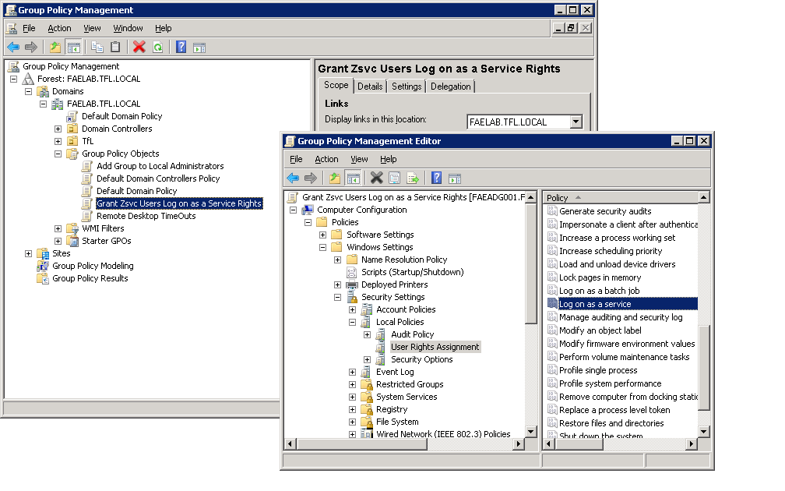

## SQL Server Instances.

The account under which the deployment will be run will require access to the SQL Server instances defined in the Deployment Config (xml) file (in <DropFolder>\Deployment\Scripts\)

## SQL Server Database File Storage

Production environments (Site-A/B, Staging and PreProd) create PARE and FAE database file groups across several SAN LUN's.

By default permission to write to the root of SAN LUN's is not inherited by the SQL Server service account (the context under which the scripts are run that configure this).

To get round this the file groups are created under a folder in the LUN mount root.

Each PARE and FAE data volume must have a directory called Data\ in them before the database deployment is executed.

Similarly the Log volume(s) must have a directory called Log\ created.

## Deployment Server

The server from which the package will be deployed requires SQL Server 2012 to be installed as sqlpackage.exe is employed in the deployment of database role s.

Also, the SQL Server 2008 versions of the following SQL Server powershell extensions are required;

* Windows Powershell Extensions (PowerShellTools.MSI)
* Sql Server Shared Management Objects (SharedManagementObjects.msi)

## External Web Servers

External web servers should have the 'Default Web Site' removed as the Customer Portal is accessed via port 80 and any server restarts will probably cause the Default Web Site to override the CustomerPortal site.

Also, the Default Web Site clouds information gathered by SCOM.

# Updating Encrypted Security Files

The same utility that is used to run post-deployment tests also handles the encryption and decryption of the Service Account files.

"<DropFolder>\Deployment\Tools\Deployment Tool\DeploymentTool.exe" -Type 'Decrypt' -ServiceAccountsFile '<DropFolder>\Deployment\Config\<env_name>.ServiceAccounts.xml' -Password '<pwd>'

This will produce a file with the passwords in plain text. The file is located in the same directory as the original with ".decrypted" added to the file name.

The relevant passwords can then be changed or new service accounts added.

Rerun the same command on the updated file but with the 'Encrypt' action type and anther file will be written called "*.encrypted.xml".

# Setup BaseData

## Setup BaseData

1. Copy the provided backup of the BaseData database to the DB Server.
2. **Site-A and Staging:** Remove Databases from HA groups before they can be deleted (See previous section for pictorial representation).
3. Restore BaseData DB backup to the same SQL Server instance that FAE is deployed to.
4. Open the Restore Files and File Groups dialog:

Right-click menu: Tasks: Restore: Files and File groups...

1. Select the From Device option and select the .bak file to restore (from step a) above).
2. Select the destination file names in the Options page

Change the file names and locations, in the Restore As column, to match those of the existing database or where they are required to be stored if this is a new database.

1. Ensure the "Overwrite the Existing Database" option if an existing db is being restored.

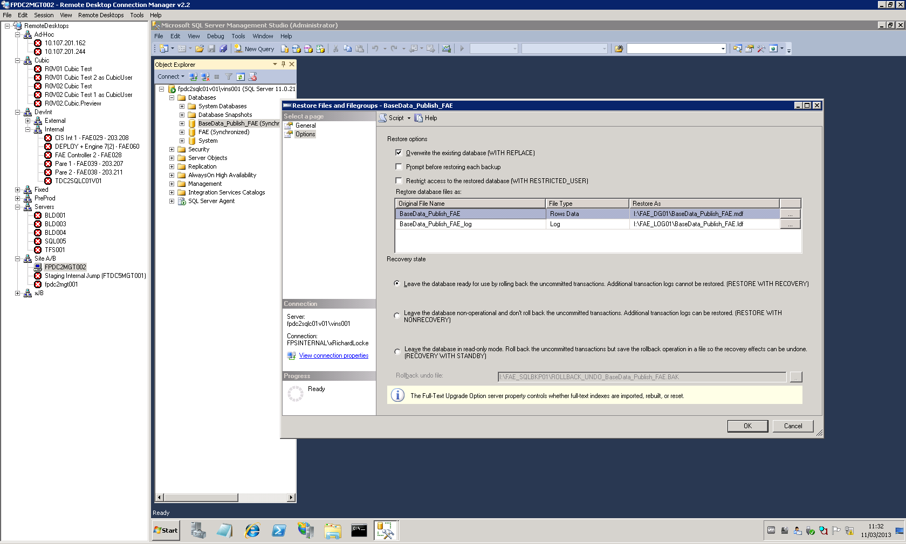

1. Give the FAE service account permissions on the BaseData DB.
2. In Management Studio select the Properties for the FAE Service Account.

Databases: BaseData_Publish_FAE: Security: Users: zsvcFAE: Properties (right click menu).

1. On the "Membership" page, check the 'db_owner' role membership.

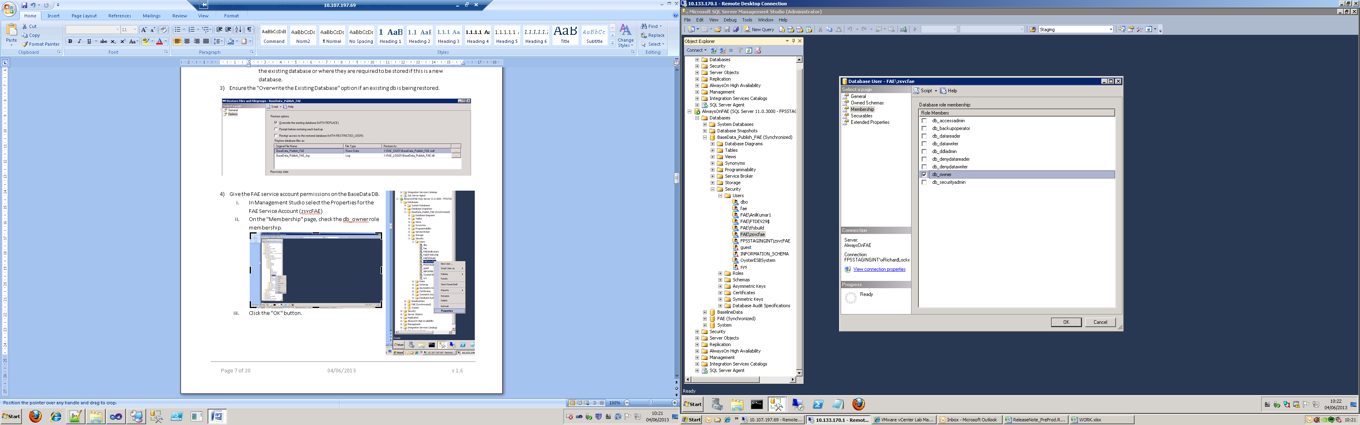

1. Click the "OK" button.
2. **Site-A** and **Staging:** Add Databases back into HA groups before they can be deleted (See section 4.1 for full details).

## Using an Alternative BaseData DB

The provider connection string needs to be updated in all *.config files that contain a connection string called "BaseData_Publish_FAE_Entity".

The easiest way to do this is to use Visual Studio to find all instances of BaseData_Publish_FAE in the <DropFolder>, and replace from there.

Do this after the package has been extracted to disk on the deployment server.

# IIS Management

## Remote IIS Management

You can use IIS Manager to connect to web servers from the jump servers but Remote IIS Management needs to be enabled.

1. Make a remote desktop connection to each of the web servers
2. Run the following commands in a dos-prompt;

> start /w ocsetup IIS-ManagementService

> reg add HKEY_LOCAL_MACHINE\SOFTWARE\Microsoft\WebManagement\Server /v EnableRemoteManagement /t REG_DWORD /d 1

> y *(user response to above required)*

> net start wmsvc

The FTPHelper.ps1 script will list the running status of all IIS sites and app pools (as well as windows services);

> powershell

> import-module ./FTPHelper2.ps1

> Get-ServiceStatusAll

You can start all windows services, across all servers with:

> Start-AllServices

# End of Day Controller Scheduling

There are 5 (at the time of writing) xml scheduled job templates that can be imported into Task Scheduler to setup these jobs. These will be either included in a Scheduling folder within the deployment package, or will be provided as an addition to the deployment packages.

They need to be created on the boxes specified and set to run under the accounts specified, see release notes for more details.

1. Start Task Scheduler

2. Create a folder to organise the tasks

*from the Task Scheduler library right-click menu*

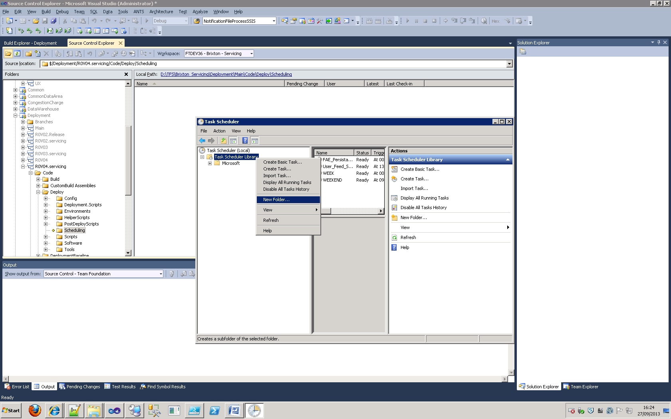

3. Import the required task templates

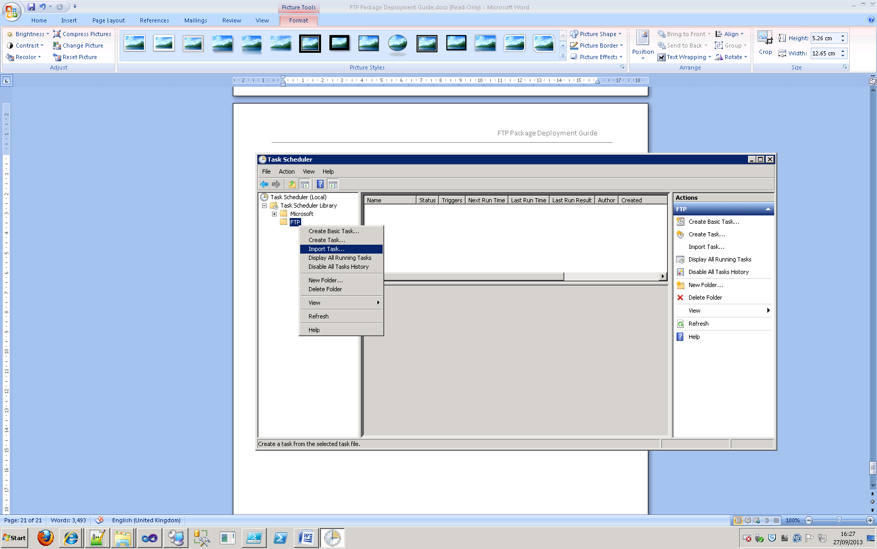

4. Edit default values as required

You can change the timing of the job in the Triggers tab of the Create Task dialog.

You can also change other standard task scheduler options in the Conditions and Settings tabs.

# Managing Clustered Services

Other Environments (with Service Clustering): Services must be stopped through the failover cluster manager.

**For Clustered Environments (all outside of Lab Manager rigs)**

Connect to the pare failover cluster (mmc->failover cluster manager) and ensure all clustered services are offline but the cluster groups and clustered storage are left online.

